To create data for wholesale trade sales order release:

- We need to create items with wholesale tagging and for each item’s barcodes should be there. (Online scripts).

- We need to enable the gold seal for those options. (Online scripts).

- We need to add stock to the items. To add the stock please use the below query. Need to replace the items in the below query.

RMS DB:
alter session set current_schema=rms;

set serveroutput on;
set timing on;

DECLARE
counter NUMBER(10) := 0;
c_commit NUMBER(5) := 0;

O_status_code varchar2(1);
O_error_message varchar2(300);
L_return_code VARCHAR2(20);
O_status VARCHAR2(20);
L_date date;
I_MESSAGE_TYPE VARCHAR2(20) := 'invadjustcre';
l_loc rms.wh.wh%type;
l_adj_qty rms.inv_adj.adj_qty%type := '200';

TYPE ITEM_REC IS RECORD
(item_id rms.inv_adj.item%type,
adjustment_reason_code rms.inv_adj.reason%type,
unit_qty rms.inv_adj.adj_qty%type);

TYPE ITEM_INFO IS TABLE OF ITEM_REC;
P_ITEM_REC ITEM_INFO;

l_RIB_InvAdjustDtl_REC "RIB_InvAdjustDtl_REC";
l_RIB_InvAdjustDtl_TBL "RIB_InvAdjustDtl_TBL";
l_RIB_InvAdjustDesc_REC "RIB_InvAdjustDesc_REC";

CURSOR cur_wh IS
select distinct wh2.wh from rms.wh wh1, rms.wh wh2 where wh1.org_unit_id!=wh2.org_unit_id and wh1.wh!=wh2.wh;

CURSOR cur_item (l_loc rms.item_loc_soh.loc%type) IS
SELECT im.item,
'201' as adjustment_reason_code
,l_adj_qty as unit_qty
from item_loc_soh im where item_parent in ('127569014','127569023','127568691','127568902','127569199') and im.loc= l_loc;

BEGIN

select vdate into L_date from rms.period;

for i in cur_wh loop
L_loc := i.wh;

l_RIB_InvAdjustDtl_REC := "RIB_InvAdjustDtl_REC"(null,null,null,null,null,null,null,null,null,null,null,null,null,null,null,null);
l_RIB_InvAdjustDtl_TBL := "RIB_InvAdjustDtl_TBL"();

open cur_item (L_loc);
fetch cur_item BULK COLLECT INTO P_ITEM_REC;
close cur_item;

FOR i IN 1..P_ITEM_REC.COUNT LOOP

l_RIB_InvAdjustDtl_REC.item_id := P_ITEM_REC(i).item_id;
l_RIB_InvAdjustDtl_REC.adjustment_reason_code := P_ITEM_REC(i).adjustment_reason_code;
l_RIB_InvAdjustDtl_REC.unit_qty := P_ITEM_REC(i).unit_qty;
l_RIB_InvAdjustDtl_REC.user_id := 'PTUSER';
l_RIB_InvAdjustDtl_REC.create_date := L_date;
l_RIB_InvAdjustDtl_REC.InvAdjustUin_TBL := null;
l_RIB_InvAdjustDtl_REC.to_disposition := 'ATS';

l_RIB_InvAdjustDtl_TBL.EXTEND();
l_RIB_InvAdjustDtl_TBL(l_RIB_InvAdjustDtl_TBL.COUNT) := l_RIB_InvAdjustDtl_REC;

END LOOP;

l_RIB_InvAdjustDesc_REC := "RIB_InvAdjustDesc_REC"(0,null,null);

l_RIB_InvAdjustDesc_REC.rib_oid :=0;
l_RIB_InvAdjustDesc_REC.dc_dest_id:= L_loc ;
l_RIB_InvAdjustDesc_REC.InvAdjustDtl_TBL :=l_RIB_InvAdjustDtl_TBL;

RMS.RMSSUB_INVADJUST.CONSUME (O_status_code,O_error_message,l_RIB_InvAdjustDesc_REC,I_message_type);

IF O_status_code = 'E' then
INSERT INTO SKUMAR.VPT_LOGS (ENTITY,ENTITY_TYPE,STATUS_CODE,ENTITY_ID,ENTITY_FROM_LOC,STATUS,ERROR)
VALUES ('INVADJ_AVAIL','ATS','FAIL',null,L_loc,O_status_code,null);
ELSE
INSERT INTO SKUMAR.VPT_LOGS (ENTITY,ENTITY_TYPE,STATUS_CODE,ENTITY_ID,ENTITY_FROM_LOC,STATUS,ERROR)
VALUES ('INVADJ_AVAIL','ATS','PASS',null,L_loc,O_status_code,null);
END IF;

c_commit :=c_commit + 1;
IF MOD(c_commit, 3) = 0 THEN
COMMIT;
END IF;

END LOOP;
commit;

EXCEPTION
WHEN OTHERS THEN
dbms_output.put_line(SUBSTR(SQLERRM, 1, 255));
END;
/

- Once stock is allocated to the items we need to give the international sku's tagging to those items in wholesale DB. Please replace the items in the below query.
insert into wholesale.WP_SKU_INT_SIZES
select item,DIFF_2,DIFF_2,DIFF_2,user,sysdate,user,sysdate from das.item_master where item_parent ='123408344';
commit;
- Now we need to create the file. Please refer the below thing.
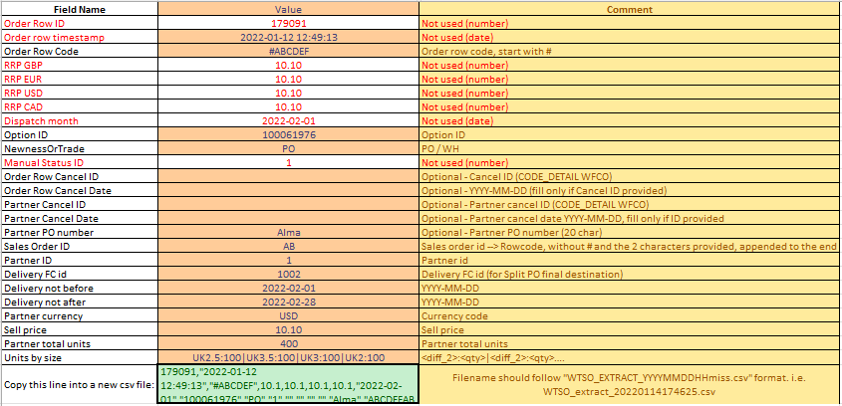

- Here is the format how we can put in notepad.
260001,"2023-07-25 08:39:53.45","#REF002",50.00,68.00,93.00,120.90,"2023-07-30","130203830","WH",4,,,,"","ALMA","REF002A1",30025,1002,"2023-07-30","2023-08-20","USD",93.00,100,"3XS:20|2XS:20|XS:20|S:10|M:10|L:10|XL:10".

